Establishment of
2010
Written by Sophak ENG
Irrigation service Center
CEDAC
a Farmer Water User Community
and Capacity building for the management
of
Machunga dam in Royor commune,
Koh Nheak District, Mondulkiri Province
Final Activity Report from April-December
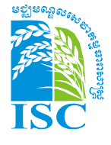
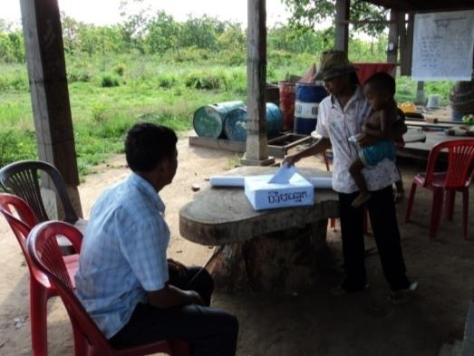
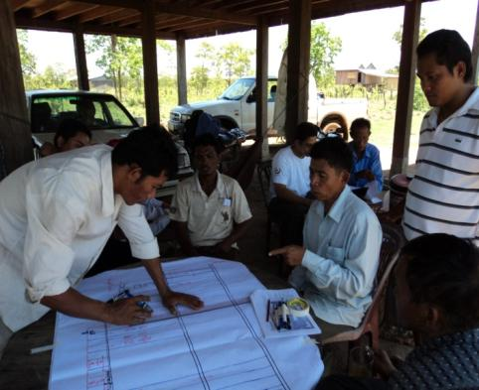
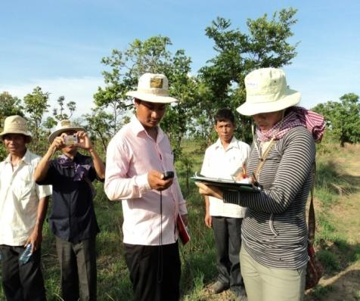
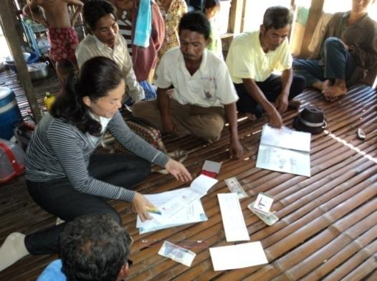
Implemented by: ISC-CEDAC
Funded by: JICA-PRDNEP

Final Activity Report from April-December 2010
13th December 2010, Written by Sophak SENG
ISC team coordinator, CEDAC
Sophak.seng@gmail.com

Establishment of a Farmer Water User Community (FWUC) and Capacity building for the management of Machunga dam in Royor commune, Koh Nheak District, Mondulkiri Province

Intruduction

PRDNEP and ExCom planned to build a new irrigation scheme: the “Machunga dam” in Royor commune, Koh Nheak district, Mondulkiri province in June 2010. The main infrastructure is one dam of 750 m in length to create a reservoir. This reservoir will be connected to a command area of 180 ha through 2 culvert outlets and 2 primary canals. This irrigation system should be able to service 40 ha during the dry season and 100 ha for supplementary irrigation during the wet season. This irrigated area is shared by 30 families of Royor village in Royor commune.

The PRDNEP and ExCom asked the Irrigation Service Centre (hereinafter ISC) to provide their expertise in Farmer Water User Community (hereinafter FWUC) support to help them to organize the FWUC that will be in charge of the Machu Nga scheme management on both water and infrastructure fields. The ISC team intervention aims to establish one FWUC for the Machu Nga irrigation scheme in Koh Nheak district, Royor commune using participatory methods.

From last week of April 2010 to 7th December 2010, ISC team started implementing his working contract in Royor commune, Koh Nheak district. As result, all 7 steps were completely done. The outcomes of these missions were a working group for establishing FWUC was formed, 83% of concerned villagers within Royor village registered and paid membership fees to become FWUC members, the first election of FWUC representative had been organized and 4 representatives of FWUC (hereinafter FWUC representatives) were elected by FWUC members, the first meeting among FWUC representatives and the first FWUC general assembly were done on 21st May 2010. FWUC statute was submitted and approved by their members, local authorities, Provincial Department of Water Resource and Meteorology (hereinafter PDoWRAM), and provincial governor on 24th June 2010. Database of FWUC had been finalized in October 2010; owner list, plot list and detail map of command area were done in ArcMap 9.3. The 4 Training sessions for the FWUC representatives on the FWUC organizational management, water management and irrigation operation, infrastructure maintenance and FWUC financial management were done from June to October 2010. The 2 follow up missions was done in July and Dec 2010, these missions were to assess on progress of FWUC and his challenge in his long run. One exchange visit for FWUC committee and working group and local authorities to learn about 3 irrigation schemes in Kampong Thom and Kampong Cham province was done from 24-27 October 2010.

Finally, missions of ISC to establish FWUC and provide capacity building to FWUC committee at Machu Nga irrigation scheme were completely done based on activities plans. However, schedule of these activities implementation was delayed 45 days. This delay was requested by ISC team, and got approval from ExCom and PRDNEP.

FWUC establishment Process and outcomes

FWUC of Machu Nga irrigation scheme was established on 18th May 2010 after evaluation result of members’ registration by working group and local authority. There were 72% of owners were registered to be FWUC members and paid membership fees, which is higher than the requirement rate of condition to form FWUC (at least 67% of concerned owners). All members received member ID card from working group, 33 out of 40 ID card of members were distributed to members who paid membership fee.

The management body of FWUC at Machu Nga irrigation scheme had been discussed and designed among working group and submitted to the first general meeting with FWUC members (27 out of 33 members) on 18th May 2010. As result of this meeting, the management body of this FWUC is called FWUC committee, which consist of 4 elected members (1 president, for general management, 1st vice chief for irrigations scheme maintenance, 2nd vice chief for irrigation scheme operation and 1 treasurer). This committee was directly elected by FWUC members.

There were 7 candidates during this FWUC committee election. Election of FWUC committee members was done on 20th May 2010, and the 4 out of 7 elected members were elected by 25 out of 33 members of FWUC.

On 21st May, working group (hereinafter WG) organized and facilitated a first FWUC general assembly with the newly elected FWUC representatives and FWUC members. Total numbers of participants were 22 out of 33 FWUC members which is equal to 67%. During this meeting FWUC committee and members approved on important issues below:
- Mandate of FWUC committee members (4 elected candidates) assigned Mr. Chen Bun is a FWUC president, Mr. Kin Pleak is 1st vice chief (maintenance), Mr. Ngin Nguon is 2nd vice chief (operator) and Ms. Bun Sinet is treasurer.
- Approved on result of FWUC member registration and total amount of collected member fee (which is 660,000Riel).
- Membership fee were kept by Mr. Thuon Uon member of WG, and was transfer to FWUC bank account in June 2010.
- Approved on temporary price of irrigation service fee (hereinafter ISF) 30,000Riels/ha in dry season and 20,000R/ha in wet season.
- A total amount of annual ISF collection would be reached to 3,200,000R base on temporary price
- Royor commune council agreed to subsidy fund to FWUC 2,000,000R per year (this needs to have official agreement between FWUC and Royor commune council)
- A draft of annual budget plan for FWUC would be around 5,200.000R per year for FWUC function, and 5 million R for annual scheme maintenance.
- Incentive for FWUC committee members is 1,200,000R for (300,000R x 4 members)
- Discussed on draft version of FWUC statute and internal regulation
- Drafted the request for the FWUC official recognition at district and/or provincial levels
- Trainings needed for their capacity enhancement

By 24th June 2010, FWUC and his management body were established, and his statute was submitted and got official approval from Royor commune council up to provincial governor. FWUC bank account was opened on 14 June 2010, at Koh Nhek district and all membership fees were deposit at his bank account.

Owner list, plot list and Map of irrigation
To be able to organize the water management, the cropping pattern and calendar and as well to prepare ISF collection, the FWUC need to have a clear record of all farmers and landowners within the irrigated area.

As result, there are 44 rice plots and 1 common area (Tuol Tonsay), which are belonging to 33 farmers. 82% (27 out of 33 farmers) paid membership fee. List of owner, list of rice plot (with code system) and digital map had been listed and drown. Lists and maps were printed and distributed to FWUC representatives and WG.

Total command areas of this irrigation scheme are 202.19 ha⁽⁾, and 44 plots were classified into 4 groups as below:

Group | Total surface (ha) | Number of plots
1 | 54.73 | 11
2 | 75.95 | 14
3 | 60.25 | 13
4 | 11.27 | 6
Total | 202.19 | 44
(More detail information about group location please refers to on map)

During these missions, ISC could not identify irrigated areas within this command area, due to little rainfall during September to October this year (2010) that was not allowed irrigation scheme to be function. The irrigated area could be identified next year if there is enough rainfall and water level in O Chba water reservoir could increase to flood the reservoir surface.

FWUC capacity building
Process of capacity building for FWUC committee members had been started from 6th June 2010 up to 27th October 2010. There were 4 training sessions were conducted since 6th June until 31 August 2010, and one exchange visit was conducted from 24^{t h} to 27th October 2010.

The first training was hold on 7th to 11th June 2010, main subjects during this training session were focused on organizing a meeting between FWUC committee members, organizing a general meeting with FWUC members, writing minute meeting, facilitating skill during meeting, how to build a trust among community members, how to lead team and how to be good leader and good follower, preparing activities plans for FWUC committee (for June 2010). During this training session, all members of FWUC committee (4 people) and 6 working group members jointed this training.

The second training was hold on 22st to 25th June 2010, main subjects were to review activities plans (for June 2010) of FWUC committee, share responsible between FWUC committee and members, define command area of irrigation schemes, define service types between FWUC committee and members (related to organize and implement water distributions and system operation), assess on scheme operation system availability (lowest and highest sport in command area), and clarify the a procedure to monitor construction activities between FWUC committee and contractor. During this training session, 3 out of 4 members of FWUC committee and 6 working group members jointed this training. The 2nd vice chief of FWUC committee were absent due to his sickness.

Third training session was held on 27th to 31st Aug 2010, main subjects were focused on scheme operation and scheme maintenances. The maintenance theory of canal, dam and reservoir were discussed (maintenance plans for beginning of each season, urgent repair during irrigated season, detail working to maintain canal and others infrastructures). It is noted that there were only discussion, but they need time to do practice more. During this training session, 3 out of 4 members of FWUC committee and 6 working group members jointed this training. The 2nd vice chief of FWUC committee were absent due to his sickness.

The Last training session was hold on 11th -16th Oct 2010, main subjects were focused on procedure to update list of owner and plot, review cropping calendar and irrigation schedule for 2011, discussion on FWUC functioning budget for 2010-2011,and tool for ISF collection. During this training session, all members of FWUC committee (4 people) and 5 working group members jointed this training.

FWUC committee exchange visit was conducted on 24th to 27th October 2010. Total numbers of participants were 9 people, 4 FWUC committee members, 1 village chief of Royor, 2 officers of Koh Nheak district, 1 officer of PDoWRAM Mondulkiri, and 1 fromPRDNEP. During this visit, all participants visited 3 irrigation schemes, where 2 irrigation schemes are locatedin Kampong Cham province (5 Kumpheak and Teuk Chha) and the 3rd one is in Kamong Thom province (Stun Chinit). The purposes of this visit were to give an opportunity to participants to see different type of irrigation schemes, and different model of irrigation management that is responsible by FWUC. As results, during reflection session with all participants they has found out some key points related to FWUC function and collaboration with local authority to collect ISF, organize meeting at beginning of each season to approve on irrigation schedule and cropping calendar and approve on financial report and budget plan etc.

The follow up missions were done two times, one in July and the last one in December 2010. 1st follow up mission was in July, and it was support FWUC committee to be strong to implement monitoring work on dam construction, and canal construction. 2nd follow up mission was in Dec 2010, it was support FWUC committee to analysis their main challenge in next coming years.

Main challenge for FWUC function in 2011 and the long run
By Dec 2010, according to the real situation, FWUC at Machu Ng irrigation scheme may face some difficulties as below:

Reservoir management
Boundary of reservoir of irrigation scheme at Machu Nga is not yet defined and has an agreement between PDoWRAM, Royor commune and farmers who are cultivating on the east and south part (on west part of O Chba bank). This could be a source of conflict for next coming year due to water level in reservoir.

Pipe installation, canal rehabilitation
For next dry season in 2011, there may be no conflict, because there will not be enough volume water in reservoir to start cropping activities. But there could be conflict during wet season 2011, they may start their crop activities with rainfall water, but they may need supplementary irrigation to survive their rice plots during drought period that could occur in July or August 2011. Pipe installation, canal rehabilitation and gate operation have to be improved before and during that period.

FWUC function practice, experiences
To organize, facilitate, and coordinate among FWUC members to have common irrigation calendar and cropping calendar, to set up principle of sharing water, to operate gate according to member requests are skills which are need to learn by doing. Taking right action when there is urgent maintenance work happen. These things, FWUC committee will face when scheme is function. They have learnt by theory, visit other place, but they still need to do by themselves, and they should have all means to implement such as tools and cash. Up to now, financial capacity is quite far from what they have. They should have at least 5 to 10 million Reils in their bank account to be ready to start their activity in next coming season in 2011. They may need this support at least during 3 seasons in order to get some experiences from these practices. They need not only cash to implement their activities but also technical support to guide them during these implementations.

Conclusion
Finally, missions of ISC to establish FWUC and provide capacity building to FWUC committee at Machu Nga irrigation scheme were completely done. FWUC is created, gotten legal recognition up to provincial level, they have received trainings, but they are at the starting point of their business. They may need technical support and financial support in next coming seasons in order to build their own experiences to operate and maintain this irrigation scheme.

The ISC team will continue to be available for a long term support would they require specific help.

-End-

Annex:
Detail Schedule of Implementation Activities from Apr-Dec 2010
Project: FWUC establishment in Koh Nheak district, Modulkiri province
Implemented by: ISC_CEDAC
 |  |  |  |  | 2010
Activities | Mar | Apr | May | Jun | Jul | Aug | Sep | Oct | Dec
Implementation Date |  | D28-30 | D1,D10-22 | D7-12,21-26 | D26-30 | D30-4 | D26-1 | D11-16,24-27 | D1-7
Step 1: Working Group Set up and Information awareness |  | w4
Step 2: Member Registration |  |  | w2
Step 3: Database Creation |  |  | w2
Step 4: FWUG/C representative selection |  |  | w3
Step 5: First FWUG/C representative meeting |  |  | w3
Step 6: FWUG/C training session/Capacity building |  |  |  | w2-4 |  | w4 | w4 | w2-4
Step 7: Follow up mission |  |  |  |  | w3 |  |  |  | w1
Prepared by ISC_CEDAC

This figure is calculated by ArcMap 9.3 software, ISC team and working group did not go and measure plot by plot at field. We used GPS to collect waypoint of each plot and transfer this information to ArcMap, then we drew polygon in ArcMap in order to calculate surface of each plot. This figure could have some error, but it could be used as reference for ISF calculation.

