FINAL NARRATIVE REPORT
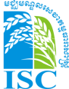
Irrigation Service Center
Irrigation component – ASIrri Project
1stJanuary 2010 to 30th September 2011

Description
  - Name of beneficiary of grant contract: GRET
  - Name and title of the Contact person:
Antoine Deligne, ASIrri coordinator, GRET – Tel. +855-89-341861 – deligne@gret.org
Seng Sophak, ISC institutional advisor, CEDAC – Tel. +855-12-993996 -
  - Name of partners in the Action:
CEDAC
  - Title of the Action:
Development of food production, farming incomes, nutrition and resilience in rural Cambodia
Irrigation component / ASIrri project / Irrigation Service Centre Project
  - Contract number:
DCI-FOOD/2009/213-720
  - Start date and end date of the reporting period:
January 1, 2010 to September 30, 2011
  - Target country(ies) or region(s):
CAMBODIA
Provinces: Kompong Thom, Kompong Cham, Prey Veng

  - Final beneficiaries&/or target groups (if different) (including numbers of women and men):

  - Country(ies) in which the activities take place (if different from 1.7):
CAMBODIA

Assessment of implementation of Action activities

Activitieslocalization and main achievements

In the framework of EU-FF project, the ISCteam hasimplemented services for 5 FWUC and 1 Farmer community for cultivating vegetable in Kampong Speu province.

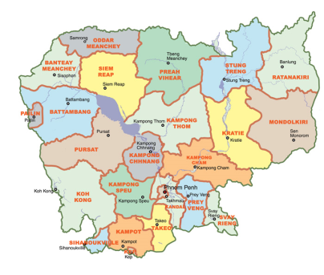
PUAC
Sdao Kong
TeukChha
Pram Kumpheak
Stung ChinitNorth
Stung Chinit East

Scheme Name | Province | Districts | Communes | FWUC/G¹ | Nb. of farmers²
Pram Kumpheak | Kompong Cham | ChamkarLeu | LveaLeu | 2 FWUG | 719
TeukChha | Kompong Cham | Prey Chhor | BengLvea  Kroch | 1 FWUC  1 FWUG | ~4448  ~725
Sdao Kong | Prey Veng | Ba Phnom  Kg Trabaek | Sdao Kong  Kansaom Ok  Kg Trabaek | 1 FWUC | 215
Stung Chinit North | Kompong Thom | Santuk | Kg Thmar  BengLvea  Prasat | 1 FWUC | 2804
Stung Chinit East | Kompong Thom | Santuk | Kg Thmar | 1 FWUG | 246
PUAC | KompongSPeu | Chhbar Mon  Samrong Tong | Chhar Mon, KandolChhrum, Roka thom,  Kahaeng,  Tangkroch,  KrangAmpel | 1 Farmer Cooperative | 156
Total beneficiaries |  |  |  | 8 FC/G
¹Farmer Water User Community / Group: one community can be composed of several groups
²Some numbers of farmers are estimated.

Activities and results

Team building and methodology

ISC team capacity building
Training and coaching provided to the ISC team members to increase their capacities for self-management in view of the ISC autonomy and for service delivery to the FWUC:

Date | Category | Subject | Participants | By
14 to 16 /01/2010 | Field exposure | Visits 4 FWUC in Kampot, Kandal and Kompong Cham | All team (8)
31/01 to 06/02/2010 | Training | Accounting and financial procedures | ISC Assistant manager | GRET finance administrator
29/03 to 02/04/2010 | Training | Report Writing | ISC Technical Advisor | SILAKA (Phnom Penh)
20/03/2010 | Training and exchange visit | Bidding procedures used by the FWUC in Prey Nup | ISC Technical Advisor and hydraulic engineer | Prey Nup FWUC director
14/07/2010 | Training | Methodology to design effective operational and water sharing rules | All team (12) | Intern (Fanny Lorgeron)
05/08/2010 | Training | GPS use, recording waypoints and transferring data to the computer for map editing | 6 staff (including engineers) | Institutional advisor (SengSophak)
16/07/2010 and 11/08/2010 | Practical training | Gauge measurement and recording, water flow measurement | 3 staff | ISC engineer
25-26/11/2010 | Workshop | Criteria method and financial support to farmer organizations | 1 staff | AVSF
21-26/02/2011 | Training and field visit | Planning maintenance (practical example in Sdao Kong) | 2 ISC engineers  3 ISC technicians  2 PDOWRAM staff  4 FWUC committee members | Hydraulic engineer (Vincent David)
9-16/03/2011 | Training and field visit | Planning maintenance and construction work monitoring (practical example in TeukChha) | 2 ISC engineers  3 ISC technicians  1 PDOWRAM staff  4 FWUC committee members | Hydraulic engineer (Vincent David)
10-11/03/2011 | Training | FWUC management evaluation methodology | 5 staff | ASIrri project coordinator
Several  May-June/2011 | Training and coaching | Quickbook software  Accounting monitoring procedures | ISC team coordinator  2 administrative staff | ASIrri project coordinator

Project management meetings and ISC institutional building

The ASIrri project management committee meets regularly with the participation of GRET and CEDAC advisers to review the project progress and its strategic orientation. In 2011, the committee discussed the future governance model of the ISC.
The project coordination committee with government partners and donors has been organized one time in August 2010.

A workshop with all potential future members of the ISC has been organized to discuss the future ISC statutes and internal rules in June 2011 in order to prepare the ISC foundation General Assembly in October.
The ISC statutes and by-laws have been written in English and will be soon translated in Khmer.

Date | Place | Participants | Meeting
02/02/2010 | Phnom Penh | 4 | ASIrri management committee
25/05/2010 | Kompong Thom | 4 | ASIrri management committee
24/08/2010 | Kompong Thom, PDOWRAM office |  | Coordination meeting to present the project progress and review its strategic orientation.  Participants: PDOWRAM director Kompong Thom, PDOWRAM officers (Kg Cham & Prey Veng), NCDD provincial staff, donor representatives, concerned district officers, ISC staff
28/10/2010 | Kompong Thom | 7 | ASIrri management committee, including GRET officer from Paris and FF coordinator
11/02/2011 | Phnom Penh | 5 | ASIrri management committee
26/02/2010 | Kompong Thom | 14 | Team meeting: Future creation of ISC as a local NGO
22/04/2011 | Phnom Penh | 5 | ASIrri management committee
23/06/2011 | Kompong Thom | 19 | Workshop on the institutional construction of the Irrigation Service Centre  Participants: all ISC team (11), CEDAC (3), GRET (2), FWUC (2), external expert (1)
24/06/2011 | Kompong Thom | 5 | ASIrri management committee

Beneficiaries selection, needs assessment, contract negotiation

Before proposing support to a FWUC or commune to improve their scheme management, the project team implements identification visits and a detailed assessment including meetings with local authorities, villagers, FWUC committee. The possibility to develop collaboration is assessed according to the following criteria:
- Scheme within the targeted provinces
- Partially functional infrastructures & reliable water source
- Existing FWUC or farmer organisation in charge
- Demand from farmers and/or local authorities
- Sufficient agricultural and economic potential
- No serious conflict
- Support from local authorities (including financial)
- Good potential for improvement
- Financial means to pay services
The weight given to these criteria rests upon the team according to opportunities.

Identification visit / assessment done:
Date | Scheme | Province | Result
25/01/2010 | KohReah | Kompong Thom | Access too difficult, risk according to government policy
20 & 26/01/2010 | Stung Chinit East | Kompong Thom | High interest from the commune
15-19/02/2010 | O Tuok | Kompong Thom | No interest from the commune, other schemes proposed
24/03/2010  June? | Sdao Kong | Prey Veng | High need to support financial management  MOWRAM subsidy request
23/03/2010 | O Veng | KompongSpeu | Some interest
31/03/2010 | O Andaeng and Neak Ta Ke dams | Kompong Thom | Need too heavy rehabilitation
15 & 19-22/07/2010 | Baray | Siem Reap | Possibility to support data base creation

Assessment had already been done and collaboration developed between the project and the following schemes before 2010: Stung Chinit North, Pram Kumpheak, TeukChha.

CEDAC team implemented a socio-economic and agriculture baseline study in March 2010 within 3 schemes: TeukChhar, 5 Kompheak and Stung Chinit North schemes. The final report is available.

Collaboration with local authorities and MOWRAM
The project selected FWUC and schemes for support following the assessment of local authorities’ involvement and active support. Where a FWUC was not very active, the ISC negotiated and contracted services directly with the communes. Thanks to the current decentralization process and the allocation of an investment fund for each commune, some communes were ready to invest in irrigation infrastructures.

In Pram Kumpheak scheme, LveaLeu commune has awarded already a 25,000,000 KHR contract to a construction company for the rehabilitation of secondary canals (2,550 m) within the scheme. These works will be implemented during the coming dry season.
In Stung Chinit East, the 60,000,000 KHR commune fund allocated the KompongThmor commune for the construction of the canal has not yet been used. The construction of the primary canal is still going on with EU and AFD funds and the commune budget will be invested for the secondary canals afterwards.
In TeukChha scheme, Boeung Nay commune invested 84,334,000 KHR for the rehabilitation of canal C embankments and silt digging. The works have been implemented between April and June 2011.

Improvement of irrigation schemes

Maintenance and improvement of Pram Kumpheak scheme
1

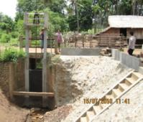
4 new structures built:

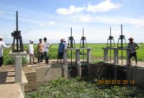
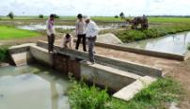
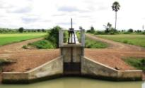
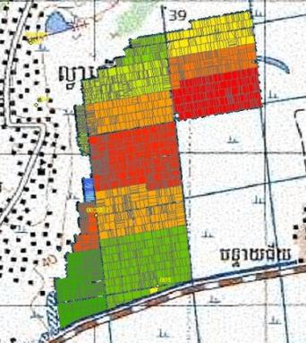
4
3
2

In Pram Kumpheak, the main gate of the PhumBey reservoir (North) was destroyed and water flowing without control, the embankment had collapsed filling the connecting canal between the gate and the reservoir. In consequence, not all water in the reservoir could be used and no control on when and how to irrigate possible. Just a few hectares close to the reservoir could benefit from irrigation. The main gate (photo 1) has been repaired and the connecting canal deepened for a better control of the water.

The main gate of the Kbal Hong Chas reservoir (South) was in proper condition, but from the gate the water flew in the main canal without any control. The farmers had to build earthen check structures within the canal to bring the water into their fields. These basic structures without gate created conflicts with downstream farmers. The commune had rebuilt with its own budget the secondary canal the year before, but there was no structure to control the water between the main and the secondary canal.The project rebuilt one check structure (photo 3) to control the water level within the main canal and one gate to control the secondary canal water intake (photo 4). At the middle of the secondary canal a triple gate (photo 2) was rebuilt to allow to raise the water in the secondary canal and to share water between downstream blocks.

The project managed this scheme improvement together with the FWUC and the commune as co-project owners. These works have been contracted to a local company for 23,200 $US in April 2010. Some supplementary works have been contracted for 2,430 $US in November 2010. All works were finalized in November 2010. These construction works have been co-funded with AFD.

Total serviced area | 497.5 ha
Number of farmers / beneficiaries | 719 households
Total cost | 25,630 USD
Cost per hectare | 51 USD/ ha

The commune agreed to invest 60,000,000 riels (~15,000 USD) from its own funds next year for further secondary and tertiary canals rehabilitation.20,000,000 riels have been awarded already for the rehabilitation of 2,500m secondary canals during the next dry season.

Impact discussion:

Before these improvements, irrigation water was available for ~40 ha double cropping (early wet season) and on approximately 40 ha more for wet season supplementary irrigation depending on years. The area with supplementary irrigation in case of limited drought during the wet season should be now effective on nearly all the area or about 400 ha.Extension of double cropping might be possible with a very strict management of the reservoir.

The exact impact of this increased controlover water sharing thanks to the rehabilitation is still difficult to estimate, as it is depending on many factors such as:
- The reservoir capacity and its natural refilling (which the works have not changed);
This information is not known and the refill is variable during the season and according to rains. A better hydrological understanding of the system functioning would require some international expertise which is prohibitive in term of cost compared to the investment. It seems more cost effective to support the farmers to build their experience practically.
- The water requirement;
As the reservoir has mainly a role for supplementary irrigation, the need for irrigation is depending on how long, how severe is the drought when it happens. In the case of a severe drought, only a limited area could be fed, whereas in a short period of drought, the reservoir could probably feed the whole area. Depending on years and situations, the irrigation system will secure a smaller or larger area.
- The farmer capacity to take efficient and fair decision in sharing water amongst them.
Due to the two factors above, the capacity of the farmers to take proper decisions according to the real situation is the real critical factor to ensure that most farmers will benefit from irrigation. This capacity is not yet sufficient as the system is used for the first time during the rainy season 2011. Our team is coaching the FWUC committee on water sharing decision making and conflict solving during this rainy season (July – November 2011) to ensure that the water will be shared effectively between farmers.

Some more secondary and tertiary canals rehabilitation and the reservoir maintenance would be required for a higher benefit. The commune is planning these investments.

Maintenance and improvement of TeukChha scheme

The maintenance of the main canal and the canal B have been implemented by a local construction company for 39,610 $US (EU-FF fund) between January and March 2011.

TeukChha scheme map
Thmar Da Reservoir
TeukChha Reservoir

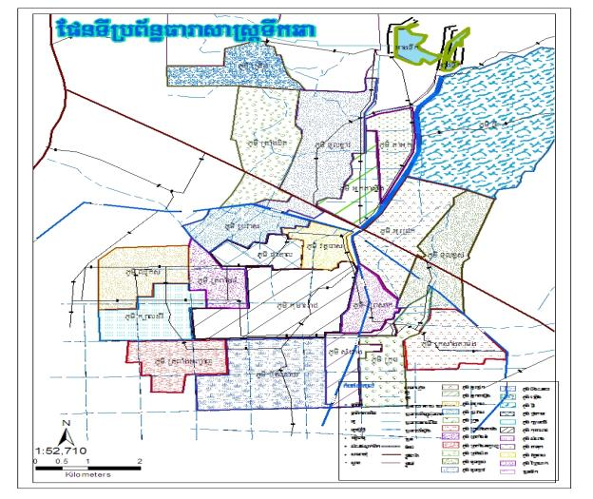
Canal B
Canal A
Canal C
~1500 ha
Main Canal
Canal maintenance with investment fund

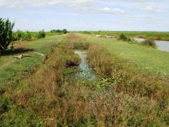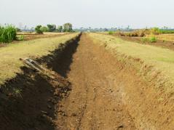
End of secondary canal B before maintenance End of secondary canal B after maintenance

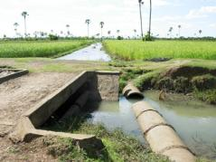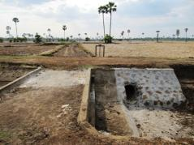
Outlet on canal B before maintenance Outlet on canal B after maintenance

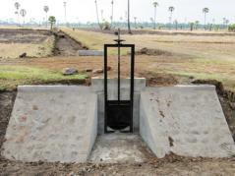
New outlet on canal B

Summary of the works done:
Works | Quantity
Outlet / gates maintenance and painting | 18 places
Outlet / gates / structures repaired | 44 places
New outlets and culverts constructions | 5 places
Main canal earth works (length = 5,069 m) | 5,539 m³
Canal B earth works (length = 5,722 m) | 7,557 m³

These maintenance / rehabilitation works should benefit to:
- The FWUC as a whole:
Total area cultivated | ~4,000 ha
Number of farmers / beneficiaries | ~4,448 households (25 villages)

- The secondary canal B:
Total area cultivated | ~1,300 ha
Number of farmers / beneficiaries | ~725 households (7 villages)
Number of FWUG members | 602 members (83% households)
Total cost | 39,610 USD
Cost per hectare | ~30 USD / ha

The Boeung Nay commune agreed to invest 80,000,000 riels (~20,000 USD) from its own funds for further secondary and tertiary canals rehabilitation. This investment has been done in April-May for the rehabilitation of the secondary canal C.

Impact discussion:
The improvements made to the main canal are supposed to benefit all the farmers within the scheme command are, however, in the point of view of upstream farmers getting water from outlets directly connected to the main canal, it may be seen differently as they used to get a permanent water flow without restriction. The repair of the gates, their locking and the new procedures for water request may reduce their capacity to access water as they want. This is of course a condition to improve water sharing on a larger scale. For the farmers accessing water from the secondary canals A & C, the improvement is still very limited due to the poor condition of their secondary canal. However this could change later on when further maintenance is implemented with the CDF or other funding.

The objective of the project was mainly to improve the quantity and the reliability of irrigation water access through the secondary canal B. The estimated command area under the secondary canal B is about 1,300 ha. Before the rehabilitation no more than 300 ha could get water from canal B and much less in case of severe drought. The water source was not the limitation, but the infrastructures condition and the incapacity to restrict water outtakes by upstream farmers. Some irrigation testing by closing upstream outlets have shown that the canal B can be filled quickly within hours and irrigation is now available on nearly the whole command area. Farmers at the end of the canal had not seen water for irrigation since before Pol Pot regime…

The possibility for irrigating the whole 1,300 ha is not depending only on the infrastructure condition, but is also depending on three other factors:
- The development and maintenance of tertiary canals:
The communes are dedicated to continue investments on the scheme, if farmer participation in the system management increases. The creation of the FWUG by the project is a strong progress in this direction. To ensure that farmers invest and maintain the system further, the key point is to start ISF collection which will require some more years of external support.
- The reservoir management:
The reservoir is used for multi-purpose: tourist leisure, fishing, other schemes irrigation, etc. A present there is no coordination between stakeholders to define priorities and ensure a fair sharing of the water. The main canal may lack water for irrigation on occasion due to bad coordination. The ASIrri project is going to support the creation of a Reservoir Management Committee in the coming month to improve the reliability of irrigation management.
- The farmer capacity to take efficient and fair decision in sharing water amongst them:
As for Pram Kumpheak scheme, the ISC Team is continuing its support to the FWUC and the FWUG of canal B to define sharing rules and implement them practically during the rainy season 2011.

Maintenance of Sdao Kong pumping station

In March 2011, one hydraulic engineer implemented a mission to Sdao Kong to prepare the maintenance plan (emergency, regular, yearly / seasonal, pluri-annual) together with ISC engineers and PDOWRAM staff. The team was informed that a Chinese company planned to destroy the main canal of Sdao Kong and to rebuild it larger. In consequence, the team decided to cancel all maintenance works on canals that had been planned under EU-FF funding.

On the same occasion, the pumping station and its pontoon which were on the edge to drown were identified as the first priority for maintenance. Over more than five years of running, the FWUC had not implemented any maintenance other than changing motor oil. The maintenance of pump and motor of this sort require specific technical capacities that were not available locally. The project negotiated with the PDOWRAM and the Department of Irrigated Agriculture from MOWRAM to implement a full maintenance of the motor and pumps as well as the pontoon. The station was brought to Phnom Penh and re-installed after one week in Sdao Kong by the DIA mechanic for 5,952 $US before the beginning of the cropping season.

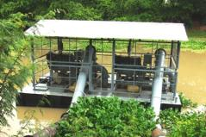
Sdao Kong motor pumps after maintenance

The DIA mechanic trained the FWUC about the pump operation, the regular maintenance requirements and provided some spare parts (filters, etc.) to the FWUC.

Number of landowners | 215 households
Total irrigated area during season 10 (Oct-Mar)  (before pump repair, according to ISF collection, largely underestimated) | 105 ha
Total irrigated area during season 11 (April-August)  (after pump repair, according to field measurements) | 265 ha
Total cost | 5,952 USD
Cost per hectare | ~22 USD/ ha

Impact discussion:

The maintenance made on the pumping station is not expected to bring any irrigated area extension per se. This maintenance was critical for the capacity of the FWUC to continue operating asthe pumps and the pontoon could have broken down any time during the coming cropping season. This scheme has been successfully operated by the FWUC since 2005, but they never properly invested in the maintenance. The fuel consumption has not been decreased too much. However the training on pump operation has shown some possibility for avoiding water losses and increasing irrigation efficiency.

Construction of Stung Chinit East canal and infrastructures

This construction project is the result of discussions hold between ASIrri project team and the commune of KompongThmor. Initially the commune contracted the team to support the creation of one FWUG that will be in charge of managing one canal that was planned to be built by the commune with its own Commune Development Fund allocated under NCDD program. The team proposed also to discuss the canal alignment with the farmers. After the team study, it appeared that the commune budget (60,000,000 KHR) was not sufficient for this project. The project proposed to complement the commune funding. Unfortunately the CDF budget could not be made available at the same moment with the project fund, so it was decided together with the commune council to allocate the commune fund to the secondary canals construction whereas the project would fund the main canal construction.

The canal is connected to an existing gate on the Stung Chinitreservoir dam. Part of the canal was previously a canal built under Pol Pot regime, but was completely destroyed by the farmers who extended their fields. The main objective of this canal is to provide supplementary irrigation for securing crops during the rainy season over 376 ha of paddy fields. It is not clear how much double cropping could be developed.

Stung Chinit East plot mapping and canal alignments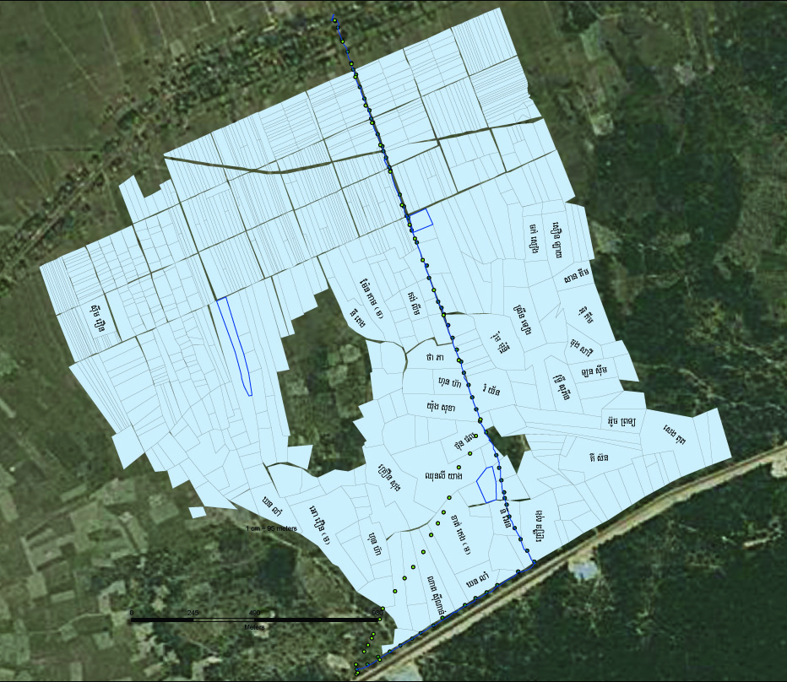
Stung Chinit Reservoir
La’ak village

Alignment: First option
Second option
Final decision
Reservoir dike

The canal alignment has been discussed with the local authorities, the farmers and engineers several times before reaching a common agreement.
The project agreed to mobilize funds for compensating the land loss due to the canal construction. The commune will own the future canal and will approve the land loss compensation on the condition that the farmers have official land titles. The PDOWRAM approved this process. The team has calculatedthe individual compensations:

Total land loss area | 40.66 a
Number of landowners affected | 32
Total compensation to be paid | 2,439,800 KHR

The project needs to edit invoices before the official payment in July.

After the alignment was approved, the design of the canal has been subcontracted to a local experienced engineer. The design was made as simple as possible to reduce maintenance costs and adapt to the farmers’ requirements. The engineer made the topographic study and estimated the construction costs. These designs have been approved by PDOWRAM. This engineer helped also to review the technical requirements for construction.

Summary of the construction works done:
Works | Quantity
Main canal earth works (length = 2,850 m) | 28,935 m³
Main gate outlet stone protection | 1 place
Embankment stone protection for canal turns | 2 places
Cart crossing bridge | 1 bridge
Check structure and outlets | 2 places

The project was approved during an official meeting of the commune council on April 9. The bidding process was launched soon after by contacting some construction companies and displaying the bidding announcement in PDOWRAM, commune and district offices. The selection committee met on May 4. This committee was composed of the KompongThmor commune chief and councillors, the Stung ChinitEast FWUG president, the Stung Chinit North FWUC president, the ISC team coordinator and the engineer, the coordinator of ASIrri project. Six companies made technical and financial offers. On May 17, the contract was awarded for 90,604.80 $US to PonloeuBanteaySrey Construction Co. Ltd. and works started quickly.A funding agreement between ASIrri project, the commune of KompongThmor and the FWUG was signed on May 17 for the same amount. The three parties are considered as co-project owners.

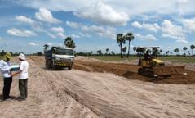
Canal construction in Stung Chinit East in June

A joint monitoring committee was established with ISC engineers and technicians, one FWUG representative and one commune councillor. Regular field visits are implemented and technical norms inspected.

On June 20, due to heavy rains, the company abandoned the works, and the contract was cancelled on June 22. The works done have been paid for 12,813.8 $US. After approval by the selection committee, the company in second position during the assessment was contracted for 84,200.25 $US (EU-FF fund and AFD ASIrri project) on July 1.

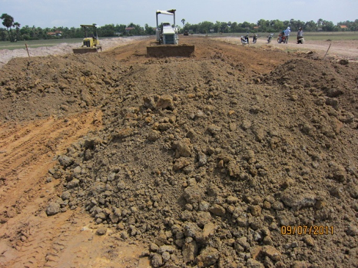
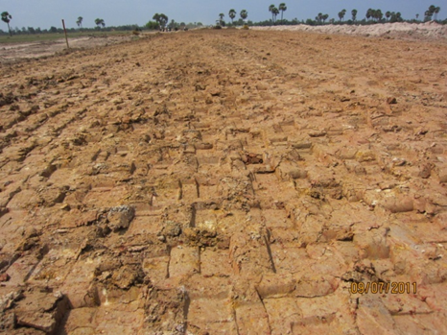

Canal construction in Stung Chinit East in July

The works were not fully achieved on September 30 due to continuous heavy rainfalls from July to end of September. About 80% of all works only were achieved, but all payments related to EU were finalized and the works are going on with AFD funding. From the 2d contract total value [84,200.25 $US], 10% [8,420.25 $US] are covered under AFD budget and 90% under EU budget. To ensure the proper management of the construction contract up to the 100% finalization, the contractor has been paid the two first instalments (45%, 37,890 $US) and the third instalment (45%, 37,890 $US) due at 100% has been paid to the FWUC bank account with the FWUC responsibility to carry out the payment as due according to the construction contract. The project team is ensuring the follow-up. 10% guarantee covered by AFD budget will be paid to the FWUC only at 100% completion expected in October.

Total serviced area | 374 ha
Number of farmers / beneficiaries | 246 households
Total cost | 97,014 USD*
Cost per hectare | 260 USD/ ha
*88,594$ paid by EU + 8,420 $ paid by AFD

Impact discussion:

The new canal shall allow irrigating 374 ha of paddy fields belonging to 246 farmers. These fields had no source of water available for irrigation previously. By securing the production during the rainy season, it is expected that some intensification will occur. The first impacts will be observed only during the next rainy season in 2012.

Maintenance of Stung Chinit North scheme

In June and July 2011, the FWUC of Stung Chinit has implemented the overall maintenance of the scheme according to the plans proposed by the FWUC representatives and validated by the General Assembly in April 2011.

The FWUC of Stung Chinit used to receive subsidies from AFD through MOWRAM during the previous years to supplement its total budget as the farmers are not yet paying 100% ISF. ISF level is increasing year by year. For 2011-2012, the FWUC requested a new subsidy from MOWRAM for its normal functioning budget, plus a complete maintenance for the whole scheme. The ISC team supported the preparation of the proposal and helped to contact with the relevant authorities. However MOWRAM had already prepared its own plans for using the maintenance fund and did not include the FWUC proposal. MOWRAM proposed to fund the FWUC maintenance only in 2012. However some important works were needed before the rainy season to ensure a proper irrigation service this year and could not be delayed for the next year.

The ASIrri project signed an agreement in May 2011 with the FWUC to fund emergency maintenance before the rainy season for 9,000 $US. The works were implemented directly by the FWUC by mobilizing local labor. The project paid the works to the FWUC based on detailed documentation for a total amount of 37,055,500 riels (~9,000 $US).

These works consist on cleaning and digging canal beds, repairing breaches in the canal embankments in several places over the whole scheme and on some small constructions such as pipe out/inlets from / to tertiary canals and check structures.
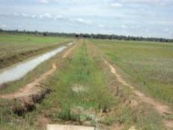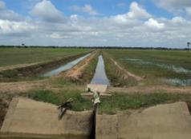
Stung Chinit North: Before and after cleaning canal bed on SC4 – TC B15

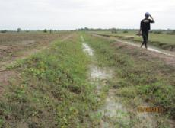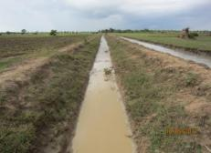
Stung Chinit North: Before and after cleaning canal bed on SC2 – TC B4

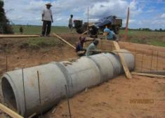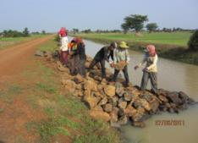
Stung Chinit North: Construction of a pipe along SC3 – TC B4 and filling stone for a check structure on SD3

Summary of the construction works done:
Works | Quantity
Cleaning canal bed (meter) | 5,789
Repair oxcart roads (meter) | 39
Clean outlets (places) | 18
Repair canal embankments (meter) | 163
Repair structures (places) | 11
Construction of new outlet pipes (places) | 4

Total serviced area | 2,400 ha
Number of farmers | 2804 households
Total cost | 9,000 USD
Cost per hectare | 3.75 USD/ ha

Impact discussion:

The main condition for the sustainability of the scheme management is to reach a funding agreement between the FWUC and the government in 2012, so that a large maintenance can be implemented. This funding was mainly dedicated to bridge the previous subsidies and future ones expected in 2012. The ISC team is dedicated to continue to support the FWUC to get access to the maintenance fund created at MOWRAM level.

The maintenance by the FWUC of Stung Chinit was implemented by local labors. It allowed to the scheme to operate normally during the rainy season. This is crucial to expect recovering the ISF from the farmers early next year.

Impact Summary

Number of farmers / households who potentially get a better access to irrigation water in term of quantity and reliability thanks to the infrastructures built:

Scheme | Province | Works | Budget | Nb. of farmers | Nb. of ha | Cost per ha
Pram Kumpheak | Kompong Cham | 4 structures construction | 25,630 $US | 719 | 497 | 52 $
TeukChha | Kompong Cham | 10,8 Km canals + structures maintenance | 39,610 $US | ~725 | ~1,300 | 30 $
Sdao Kong | Prey Veng | Pumping station maintenance | 5,952 $US | 215 | 265 | 22 $
Stung Chinit East | Kompong Thom | 2,850 m main canal + structures construction | 97,014 $US | 246 | 374 | 260 $
Stung Chinit North | Kompong Thom | Small maintenance | 9,000 $US | 2,804 | 2,400 | 3.75$
Totals |  |  | 177,206 $US | 4,773 | 4,836

Strengthening FWUC and FWUG management

Creation of FWUG

During the funding period, the ASIrri project has supported the creation of Farmer Water User Groups (FWUG), a subdivision of a FWUC, in 3 schemes in order to reactivate the farmer participation in irrigation management.
This support includes:
- Creation of a temporary Working Group (WG) including commune representatives and village chiefs;
- Membership rules definition together with the WG;
- Village meetings to inform about the establishment of the FWUG and membership rules
- Membership registration and membership fee payment;
- General FWUG governance model definition and election procedures with the WG;
- Identification of candidates to become FWUG representatives and training for the candidates;
- Election;
- Training for the new elected FWUG committee about the functions and the role of the committee;
- Organize an exchange visit with the FWUG committee and the TAC to an experienced FWUC;
- Bank account opening for the FWUG to deposit the collected membership fees;
- Review the draft FWUG statutes and internal rules with the FWUG committee;
- Prepare an action plan;
- General and/or Village assembly meetings to validate the Statutes and Internal Rules, inform about the membership registration result, present the FWUG action plan and approve the payment of the service;

Results:
Follow-up indicator | Pram Kumpheak | TeukChha  Canal B | Stung Chinit East  La’ak
Service signed on | October 2009 | May 2010 | May 2010
FWUG created | 2 | 1 | 1
WG members | 7 | 9 | 7
No of village meetings | 19 | 16 | 7
Nber of participants to village meetings | 548 | 340 | 182
Nber of members registered | 497 | 602 | 221
%age of all landowners | 64% | 83% | 76%
Membership fee (KHR/member) | 15,000 | 15,000 | 10, 000 (<0.5ha)  20,000(>0.5ha, <1ha)  30,000 (>1ha)
Total MF collected (KHR) | 7,445,000 | 9,130,000 | 5,365,000
Election date | 28/01/2010 | 26/10/2010 | 20/12/2010
Participants to elections | 439 | 568 | 172
Elected committee representatives | 2 * 3 | 7 | 3
WG & FWUG committee trainings (days) | 20 | 20 | 15
Bank account opening | Yes | Yes | Yes
Exchange visit place / date | Stung Chinit  13/01/2010 &10/12/2010 | Stung Chinit  08/12/2010 | Stung Chinit  31/01/2011
Exchange visit participants | 21 &13 | 15 | 5
Action plan | Structures rehabilitation and cropping calendar | Canal B maintenance and improvement | Canal alignment and construction
GA / Village assemblies meeting dates | 2 FWUG GA  09/04/2010 | 7 village assemblies  13 to 16/06/2011 | 1 FWUG GA  29/07/2011
GA / Village assemblies participants | 259 | 287 | 38
Statutes approved and printed | Yes | Not yet | Not yet

FWUC/G committee capacity building

C.2.1. Services for operation and water management

Support to operation and water management was provided to 3 schemes:
- Pram Kumpheak
- TeukChha
- Sdao Kong

During the rainy season 2010, the ASIrri project team has supported the decision making processes for water sharing in two schemes: Pram Kumpheak and TeukChha. The team organized regular meetings and information meetings at village level. The discussions helped also to identify key constraints in the water management to prioritize scheme improvements. The support to establish rules and procedures for conflict resolution is going on during the rainy season 2011.

In April 2011, after repairing the pumping station, the team trained the FWUC committee in Sdao Kong about operation for reducing water losses and improving the water efficiency.

 | Pram Kumpheak | TeukChha | Sdao Kong
Season | Rainy season 2010 | Rainy season 2010 | Season 11 (April 2011)
Support | Committee meetings & village meetings facilitation | -Creation of an advisory committee  -Committee meetings & village meetings facilitation  -Recruitment of 4 gate operators | Training for the FWUC committee
Nber of committee meetings / participants | 15 meeting  7 participants per meeting | 10 meetings  25 participants per meeting | 25 to 29 April 2011  5 participants per meeting
Nber of village meetings / participants | 6 village meetings  11 to 12 /03/2010 | 20 village meetings  922 participants | 2 villages meeting  39 participants

C.2.2. Support for scheme improvements

The team accompanies the FWUC and the commune for the scheme improvement from the identification phase to the construction monitoring and final reception. The supports include:
- Field identification
- Infrastructure design and costing
- Project approval by PDOWRAM, NCDD and district / province
- Preparation of bidding documents
- Training about bidding procedures, offer assessment and coaching during evaluation
- Contract preparation
- Participation to joint monitoring committee during construction
- Control by engineers according to quality requirements

These supports have been implemented for all the construction and maintenance works detailed above: Pram Kumpheak scheme improvement, TeukChha maintenance and Stung Chinit East canal constructions. Infrastructure designsare prepared by consultant experienced engineers.

C.2.3. Service for database creation and update

The ASIrri project created GIS plot database for three schemes: Pram Kumpheak, Stung Chinit East and Sdao Kong. This work involves the following tasks:
- creation of a sketch map with the local farmers;
- identification of all landowners;
- field collection of waypoints with GPS;
- map drawing on ArcGIS system;
- linking the plot database with the landowners and members lists;
- editing and printing the maps and the database with a common reference system.
Detailed plot maps with references and database tables have been provided to the 3 FWUC. The team will continue to use these databases to support ISF collection and irrigation follow-up at field level.

Indicator | Pram Kumpheak | Stung Chinit East | Sdao Kong
Nber of waypoints collected | 4,421 | 1,910 | 936
Nber of plots | 2,198 | 814 | 410
Nber of landowners | 719 | 246 | 215
Exact scheme area | 497.49 ha | 373.83 ha | 264.61 ha

The project also supported the regular update of the existing database in Stung Chinit North and the edition of the ISF invoices sent to the farmers before ISF collection.

C.2.4. Services for budget and financial management and reporting

The ASIrri project supported the financial management in four schemes.

- For two FWUC, Pram Kumpheak and TeukChha, the team trained the FWUC committee to elaborate a budget plan for the end of this year.

- For Stung Chinit North, the team ensures the accounting follow-up and support the budget elaboration for two years: April 2010 to March 2011and April 2011-2012. The team created a new accounting system on Excel for the FWUC to facilitate the financial follow-up. The team supported the FWUC to request subsidies to MOWRAM in 2010 and in 2011. The FWUC received about a 29,137$ subsidy in 2010. For 2011, the requests have been unsuccessful up to now. The team produced a financial report for the FWUC to be sent to MOWRAM.

- For the Sdao Kong, the team opened a new bank account and supported the set-up of new financial procedures. The FWUC received a subsidy from MOWRAM in July 2010. The project supported the FWUC accounting, ISF collection and financial reporting, including organizing village meetings to present the financial results and discuss ISF collection. The season 10 financial report has been produced by the team and sent to PDOWRAM. These supports are continuing for the season 11.

Activity / Indicators | Stung Chinit North | Sdao Kong | Pram Kumpheak | TeukChha
Budget planning | Yes | Yes | Yes | Yes
Period of planning | Year 2010-11  Year 2011-12 | Season 10*:  Oct 2010 – Mar 2011  Season 11:  April – Aug 2011 | Jun-Dec 2011 | Jun-Dec 2011
Yearly / Seasonal budget | 174,889,400 KHR | 24,590,000 KHR*  33,535,000 KHR | 16,800,000 KHR | 46,295,000 KHR
Financial management procedures | Develop new accounting system | Training & follow-up  Bank account opening | Bank account opening | Bank account opening
Accounting follow-up | Yes on Excel | Yes on Excel | Not yet | Not yet
Subsidy request preparation and follow-up | -Subsidy for 2010-11: MOWRAM provided 120,011,700 KHR  -Subsidy request for 2011-12. | -Subsidy for season 10: MOWRAM provided  26,863,000 KHR.
ISF collection procedures |  | Training& coaching | No ISF yet | No ISF yet
ISF collection follow-up | Yes | Yes
Total ISF collected | 76,800,000 KHR | 13,170,800 KHR
%age collected | 80% | 95%
Financial report preparation | Report year 2009-10  Report year 2010-11 | Report season 10  Report season 11
Total expenditures | 177,703,300 KHR | 16,480,000 KHR
Report presentation to members |  | 4 village meetings  21 to 24 /03/2011  Participants: 40/64

C.2.5. Other services

Outside support to FWUC, the project signed a service contract with CWPD for the writing of financial procedures for the Peri Urban Agricultural Centre (PUAC) a farmer cooperative selling vegetables. Several missions to review procedures aboutcash management, purchase and sales procedure, bank cash flow and financial reporting were implemented and a presentation to discuss the proposed procedures. A final document was produced and handed over to the PUAC.

Date | Purpose of Mission to PUAC
24-25/08/2010 | PUAC background & organization
14-15/10/2010 | Procedure analysis
13-14/12/2010 | Procedure analysis
20/12/2010 | Procedure analysis
18/03/2011 | Presentation and final discussion on the draft document
08/04/2011 | Delivery of the final document

FWUC networking

CEDAC has been supporting regular exchanges ad discussions between FWUC representatives since several years. The ASIrri project continued this support with the aim to formalize these meeting, so that this network can have more visibility and represent the FWUC in different arenas. The ASIrri project has enlarged the number of FWUC participating to these meeting and supported the formal organization of the Farmer & Water Net (FWN).

The members of the FWN are:
 | FWUC name | Province | System type | Scheme size¹ | Number of farmers² | Year of registration
1 | Prey Nup | Preah Sihanouk | Polder | 10,492 ha | 6,385(in 2006) | 2000
2 | Sdao Kong | Prey Veng | Pumping station | 265 ha | 215 | 2004
3 | O Treng | Kg Speu | Diversion | ~1,000 ha | ~1,000 | 2001
4 | O Veng | Kg Speu | Reservoir | 514 ha | ~500 | 2003
5 | Prek Ta Roat Ta Ong | Kandal | Flood protection dike – Prek | 321 ha | 529 | in process
6 | Kok Thnot | Kg Cham | Lake flood reservoir | 240 ha | 100 | Districtlevel  2006
7 | PramKumpheak | Kg Cham | Reservoir | 492 ha | 719 | 2003
8 | TeukChhar | Kg Cham | Reservoir | 4,212 ha | 4,448 | 1999
9 | StungChinit | Kg Thom | Major river diversion | 2,400 ha | 2,804 | 2002
10 | TrovKord | SiemReap | Diversion | ~400 ha | 240 | in process
11 | Baray | SiemReap | Reservoir | 1,958 ha | 2,496 | 2003
12 | Ponley | BanteayMeanchey | Reservoir | 400 ha | 438 | 2009
1: Command area or irrigated area during the main season / wet season
2: Some numbers are only estimations depending on the information system quality for each scheme

These 12 FWUC members represent approximately 20,000 farmers or farmer families and 23,000 ha irrigated.

C.3.1. Exchange visit and meetings between FWUC

3 exchange visits and meetings have been organized in 2010:

Date | Place | Participants | Activity
26/03/2010 | Phnom Penh | 10 FWUC  11 people | Review of experiences, discuss membership and evaluation procedures
26-28/05/2010 | Siem Reap | 12 FWUC  13 people | Exchange visit to 3 schemes: Baray, Trov Kord and Tumnup Rumdeng  Meeting at Pdowram to review experiences in scheme development and membership
18-19/10/2010 | Phnom Penh | 12 FWUC  23 people | Discuss FWN future statutes and internal rules

C.3.2. Participatory evaluation of all members

All FWUC, FWN members have been visited by the ISC team to carry out an evaluation of their current management between March and May. On these occasions, the final Statutes of FWN and the membership registration procedures were explained to the full FWUC committees (not only the representatives sent to FWN meetings).

Visits program for evaluations:
FWUC name (Province) | Date of evaluation | Category according to evaluation results
TrovKord(SR) | March, 21 | I
Baray (SR) | March, 22 | I
Ponley (BMC) | March, 23 | II
Po Pi Daem (BMC)* | March, 24 | II
Pram Kumpheak (Kg Cham) | April, 5 | I
Prey Nup (Kg Som) | April, 19 | V
Stung Chinit (Kg Thom) | April, 22 | IV
TeukChha(Kg Cham) | April, 25-26 | I
Sdao Kong (Prey Veng) | April, 26 | III
KokThnot (Kg Cham) | April, 27 | II
Prek Ta Roat (Kandal) | April, 29 | III
O Veng (Kg Speu) | May, 10 | III
O Treng (Kg Speu) | May, 11 | III
*Non-member of FWN

The project developed an evaluation methodology for FWUC with the review of 33 criteria scaled into five categories. These criteria review the main functions of the FWUC: operation and maintenance, institutional organization, ISF collection, financial management, institutional relations… To reach one category, the FWUC needs to reach a satisfactory level for all the criteria in this category.

Category | Description
0= Not operational | Irrigation is not (yet) available: scheme under construction or too damaged or not sufficient water resource available
I = Partially operational | Irrigation is at least partially available and there is some farmer management, but very low performance, no clear organization between farmers, or less than one year experienced
II = Institutional construction | The scheme is managed by an active FWUC with clear membership and an elected committee, but management level is weak: the FWUC can ensure only the basic scheme operation
III = Basic management | The FWUC operates the scheme and implements some emergency maintenance. The FWUC try to collect ISF, but the amount and the percentage collected are low. The FWUC organizes yearly village or general assemblies
IV = Experienced management | The FWUC has at least 3 years experience and collects ISF at a good level; it has a budget and a good financial management. It ensures a regular maintenance, but still insufficient on the long term.
V = Expert management | The FWUC is financially and technically autonomous and sustainable. Financial control systems are in place. Maintenance is sustainable over the long term. The FWUC has signed a responsibility sharing agreement (MoU) with MOWRAM

Example of evaluation result:

C.3.3. FWN foundation general assembly

Date | Place | Participants | Activity
26-27/05/2011 | Stung Chinit | 12 FWUC  24 people | Foundation general assembly:  - Statutes validation  - Membership validation  - Evaluation review  - Election  - Official ceremony  Exchange visit to Pram Kumpheak

On May 26-27, the Farmer & Water Net hold their first (foundation) general assembly in the office of the FWUC of Stung Chinit with 24 FWUC representatives (2 representatives per FWUC: the FWUC president and another committee member).
On 26, morning, the FWN statutes were presented, discussed and the final version approved unanimously article by article.
On 26, afternoon, the evaluations of each FWUC were presented and discussed to determine for each FWUC, whether it can become a full member of the Network or only a learning member. FWUC can become full member only if they reach the category II. According to their evaluation, 4 FWUC became learning members and 8 full members.
After paying the membership fee, the membership was validated by the full assembly and candidates for the FWN board identified.

On May 27, the members elected one president, one vice-president and one treasurer amongst five candidates:
President: Mr. Yim Boy, president of Prey Nup was elected by 20/23 votes.
Vice-president: Mr. Kong Sok, president of O Veng was elected by 14 / 23 votes.
Treasurer: Mr. KeamBunrong, president of Stung Chinit was elected by 13 / 23 votes.

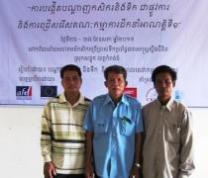
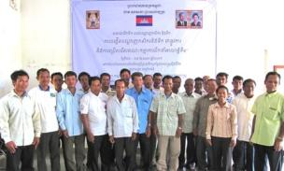
Farmer & Water Net group photo during the 1st General Assembly Theelected board

After the election, a ceremony was organized with Buddhist monks’ prayers and official speeches. The officials who attended the ceremony are:
- One MOWRAM representative: the vice-director of FWUC Department
- The director of PDOWRAM in Kompong Thom
- The district governor
- GRET and CEDAC representatives
A press release was sent to the radio and journals in Khmer language. The event was broadcasted on television as well.

On July 28, 2011, the FWN board met in Phnom Penh at CEDAC head office to prepare their activity plan for the year and the next exchange visit and meeting planned in October.

The FWN still need to get an official logo and to start registration at the Ministry of Interior. The project is waiting for the new legislation for association registration to be passed, before launching the registration process.

Contracts
Over 10,000 $US

Contract | Purpose | Amount
Pram Kumpheak | 4 structures construction | 23,220.90 $US
TeukChha | 10,8 Km canals + structures maintenance | 39,610.00 $US
Stung Chinit East | 2,850 m main canal + structures construction | 1st contract: 90,605.00 $US  Paid after contract cancellation: 12,813.80 $US  2d contract: 84,200.25 $US  (including 8,420.25 $ paid by AFD)

Continuation after the end of EU-FF funding

The ASIrri project is still funded up to end of June 2012. Follow-up activities and support to the FWUC who have benefited from EU-FF funding will continue at least up to this time. The ISC has signed several new service contracts with those FWUC to continue supports on operation, maintenance and general management. The ISC is looking for new funding to be able to continue these supports over several years.

Partners and other Co-operation
- CEDAC
GRET and CEDAC have signed a partnership agreement and have set up a Project Management Committee for ASIrri. This committee meets every 3 months, evaluate the progress, discuss and take strategic decisions related to the Irrigation Service Centre management and activities.CEDAC provides one institutional expert to the ISC team and specific expertise missions.

- PDOWRAM of Kompong Thom and local authorities
GRET has signed a Memorendum of Understanding with Kompong Thom PDOWRAM in 2009 and is collaborating closely with other province, local authorities at commune, district and province level.

The team has ensured that all activities are approved by local authorities and are implemented with their involvement.The team is working with the commune councils to encourage and help them to use the Commune Investment Fund (CIF) from NCDD for irrigation development, contributing to the government efforts towards decentralisation.
The ISC provide services under contract with FWUC and communes, especially where communes intend to invest their CIF provided by NCDD in irrigation infrastructures. It allows them to increase their financial capacities to implement those works, but also to get relevant technical inputs and follow-up.

Visibility
Visibility boards mentioning donated by EU and including EU flag have been displayed on the new constructed structures in Pram Kumpheak and TeukChhar scheme in Kompong Cham.

